**Sunday 12/30/2018 to Saturday 1/5/2019**

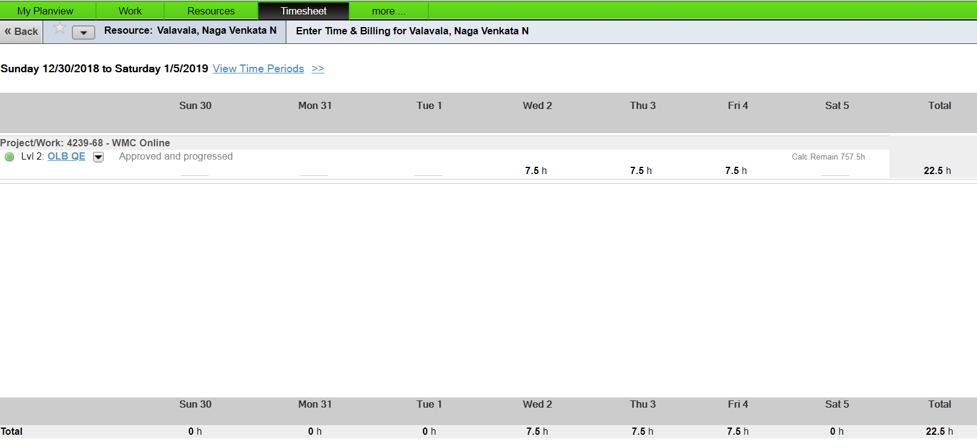

**Sunday 1/6/2019 to Saturday 1/12/2019**

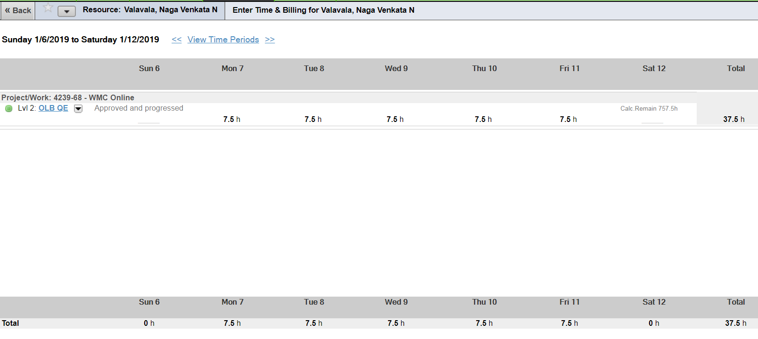

**Sunday 1/13/2019 to Saturday 1/19/2019**

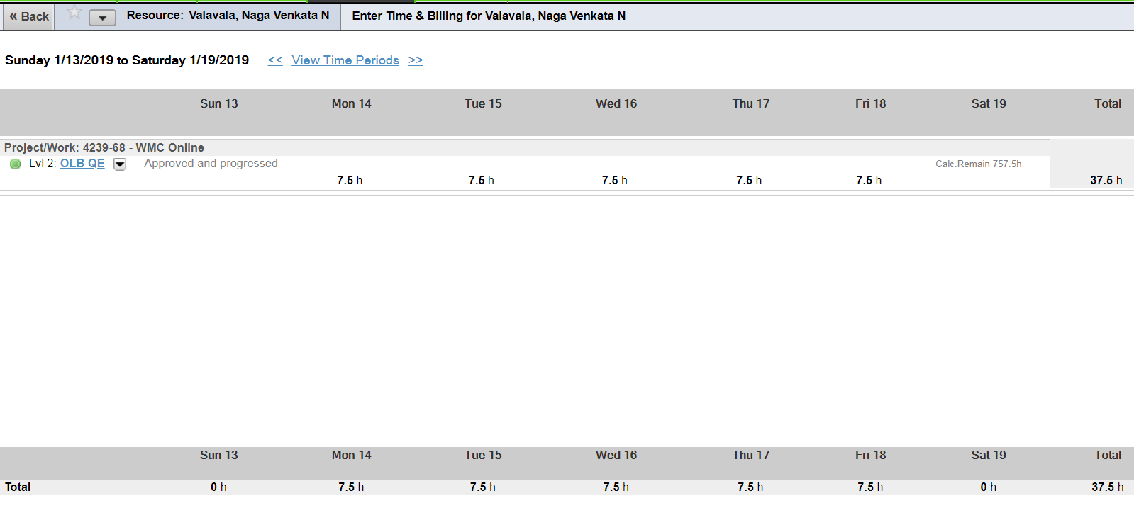

**Sunday 1/20/2019 to Saturday 1/26/2019**

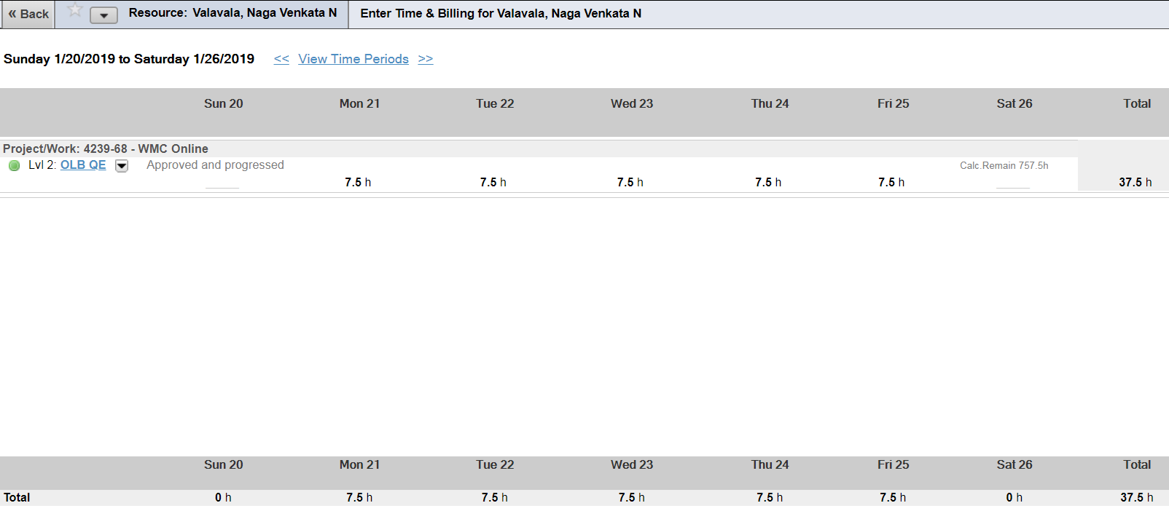

**Sunday 1/27/2019 to Thursday 1/31/2019**

